6th Workshop of SeS - accommodation in student houses

Participant | Student house | Room type | Arrival | Departure
Vito Lippolis | T-19 | Guest room (single) | 21 September | 24 September
Piotr Kiełbasiński | T-19 | Guest room (single) | 21 September | 23 September
Józef Drabowicz | T-19 | Guest room (single) | 21 September | 23 September
Luca Sancineto | T-19 | Guest room (single) | 17 September | 22 September
Anca Silvestru | T-19 | Guest room (single) | 21 September | 25 September
Alexandra Pop | T-19 | Guest room (single) | 21 September | 25 September
Tomasz Cierpiał | T-22 | Regular room (single) | 21 September | 23 September
Paolo Santoni | T-22 | Regular room (single) | 20 September | 24 September
Małgorzata Marć | T-22 | Regular room (single) | 21 September | 24 September
Roxana Popa  Emilia Popa | T-22 | Regular room (double) | 21 September | 25 September
Julianna Mruk  Magdalena Obieziurska | T-22 | Regular room (double) | 21 September | 23 September
Francesca Mangiavacchi  Martina Palomba | T-22 | Regular room (double) | 20 September | 24 September
Bonifacio Monti  Rosa Trilli | T-22 | Regular room (double) | 20 September | 24 September
Ester Giorgi  Samuel Simoni | T-22 | Regular room (double) | 20 September | 24 September
Giulia Di Salvo  Sara Pompei | T-22 | Regular room (double) | 20 September | 24 September
Francesca Giulia Nacca Agata Miriam Russo | T-22 | Regular room (double) | 20 September | 24 September
Marianna Francesca Pensa  Margherita Cardinali | T-22 | Regular room (double) | 20 September | 24 September
Lisa Della Rina  Sofia Alocchi | T-22 | Regular room (double) | 20 September | 24 September
Francesca Begini  Vittoria Chiericoni | T-22 | Regular room (double) | 20 September | 24 September
Gloria Cappelloni  Lucia Capoccia | T-22 | Regular room (double) | 20 September | 24 September
Orsola Merlino  Elisabetta Coarelli | T-22 | Regular room (double) | 20 September | 24 September
Emanuela De Monte Elisabetta Scarcella | T-22 | Regular room (double) | 20 September | 24 September

Both student houses T-19 and T-22 are situated on Wittiga Street (Figure 1). There is a tramway and bus stop called “Tramwajowa” that can be reached using tramway lines number 1, 2, 4 or 10 and buses number 145, 146, 253 or 256.

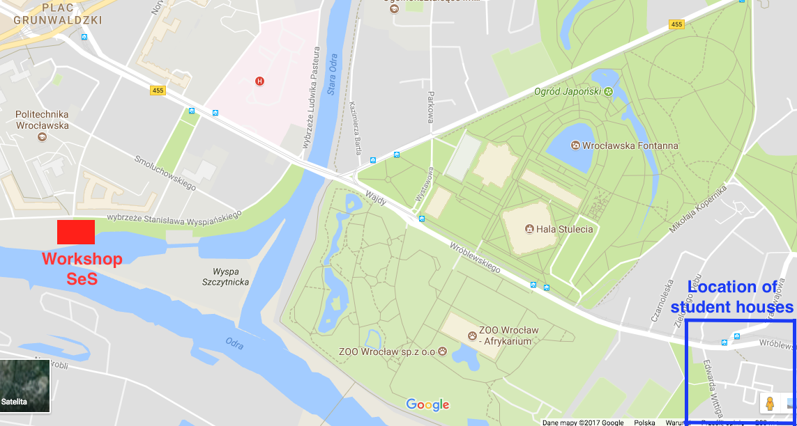

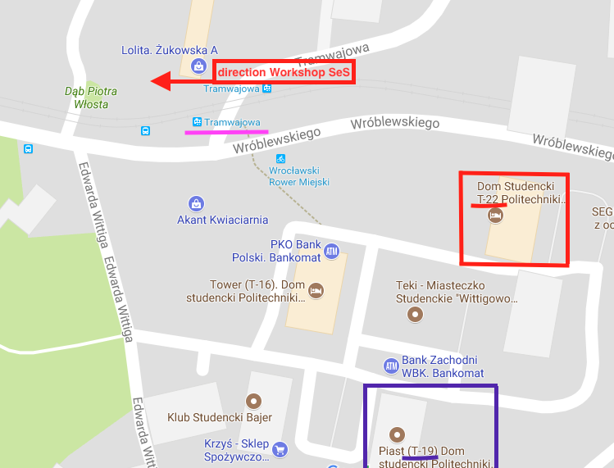

Figure 1. Location of student houses.
Guest rooms are situated in the T-19 building.
Regular rooms are situated in the T-22 building.
Price for guest rooms is 90 PLN for place/night
Price for regular rooms is 65 PLN for place/night

Guests will need to present an identity card prior to registration in student house.
Payment for the accommodation can be made only with credit card. Cash payments will NOT be accepted.
Invoice can be issued at the end of the stay on a specific request of the interested party.

There is a reception in each building that is normally open 24/7. Upon registration each guest will receive a key to the room and additional key to the entrance to the building. Please let us know if you plan to arrive late in the night (after 10 pm) then we will additionally inform the reception of the student house.

Regular rooms are equipped with two single beds (bedding and towels included) (Figure 2). There is one bathroom for two regular rooms (soap, shampoo, toilet paper etc not included). Additionally, there is one common kitchen on each floor. The kitchen is equipped with 2 electric ovens and 2 electric hot plates.

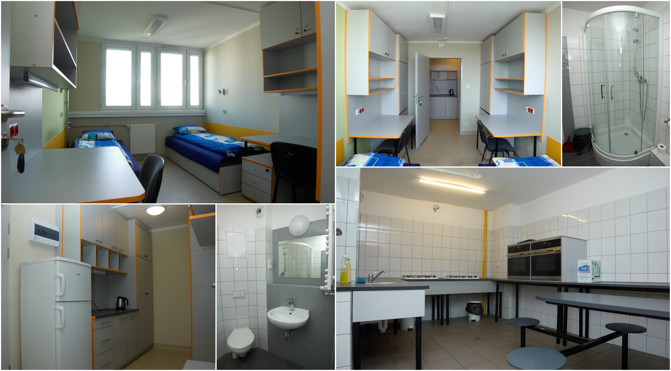
Figure 2. Regular rooms in building T-22.

Guest rooms are equipped with a single bed (bedding and towels included), small fridge, small kitchen and private bathroom (Figure 3).

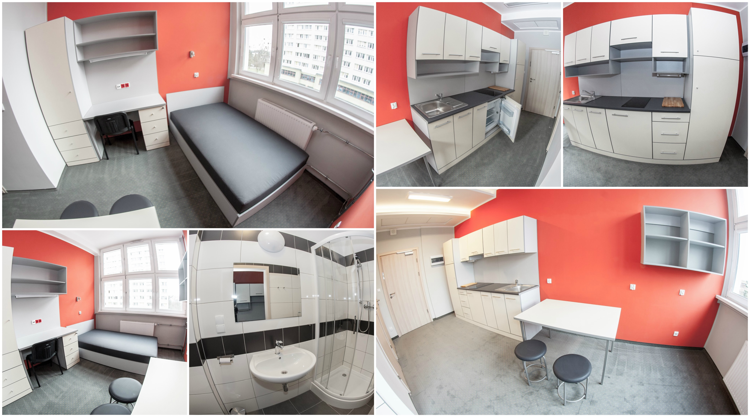
Figure 3. Guest rooms in building T-19.

