Recovery of lanthanides from NdFeB permanent magnets
Anna Dańczak
According to the European Commission, about 13% of the worldwide mining output of neodymium is used for the manufacturing of neodymium-iron-boron (NdFeB) permanent magnets. These magnets are essential materials in energy saving and digital equipment such as hard disk drives (HDDs), highly efficient air conditioners, hybrid vehicles and wind power generators. NdFeB magnets contain about 30% of REEs (mainly neodymium, praseodymium, dysprosium and terbium). All of these rare earth elements are considered as critical metals by the European Commission.
NdFeB permanent magnets derived from end-of-life computer hard disc drives (HDDs) are particularly promising sources of lanthanides. Due to the rapid aging of electronic devices, HDDs and computers are often replaced with new equipment. Estimates show that the annual weight of waste magnets in Poland is about 50 tonnes. With an average lanthanide content of 30%, this gives about 15 tonnes of these raw materials. Therefore, the recycling of NdFeB magnets from waste hard disk drives (HDDs) can be a significant source of REEs.
In recent years, great efforts have been made to develop the recycling methods, as described in many review works. Hydrometallurgical methods, intensively investigated, consist of several unit operations, namely demagnetization, crushing and milling of demagnetized magnets, oxidation of obtained powders, leaching, separation of lanthanides from iron and finally separation of individual lanthanides. The combination of so many unit operations, easy to carry out on a laboratory scale, negatively affect the applicability of hydrometallurgical methods on an industrial scale. The operations of milling and roasting oxidation affect the economic viability of the recycling process by increasing the costs.
The main objective of the presented work was the elaboration of a simple, cheap and effective method to recover lanthanides from permanent magnets. The proposed method is based on hydrometallurgical treatment. In this work, the possibility of simplifying the process of hydrometallurgical NdFeB magnet recycling, by the elimination of milling and roasting oxidation, was studied.
The method of lanthanide recovery from NdFeB permanent magnets elaborated in this work differs from the methods described in the literature. The most notable advantage is the elimination of many unit operations, which simplifies the whole recycling process. The scheme of the elaborated method is presented in Fig. 1.
In the developed method, demagnetized and broken magnets are subjected as the feed in the leaching process with the use of hydrochloric acid solution as the leaching agent. The leaching process is carried out at room temperature and in atmospheric pressure. The solid leach residue (undissolved magnet pieces and nickel) is recycled to the next leaching process. Lanthanide ions are separated from the other components of the leaching solution by direct precipitation in the form of oxalates. After separation of lanthanide oxalates, the obtained solution, after adjusting the hydrochloric acid concentration, is recycled to the next leaching cycle. The lanthanide oxalates are subjected to thermal decomposition to oxides after washing with water.
The results obtained in pilot scale (1 kg per batch) confirmed the results obtained in laboratory scale (14 g per batch). The recirculation of process solution allows achieving efficiency of >99%, both in relation to the leaching process and the precipitation of lanthanide oxalates.
Based on the results of this work, it can be concluded that:
- NdFeB permanent magnets are heterogeneous material - the composition changes in a wide range and is not connected to the HDDs parameters;
- unit operations of crushing and grinding magnets, as well as oxidation roasting can be eliminated from the recycling process;
- the whole magnets (without previous demagnetization, crushing, breaking, milling or oxidizing) can be subjected as feed material in the leaching process;
- the use of broken magnets after demagnetization as the feed material allowed achieving practically 100 % efficiency of leaching and about three times higher concentration of REE ions in the obtained solution;
- the use of hydrochloric and sulfuric acid solutions as the leaching agents allowed selective leaching of NdFeB magnets while leaving nickel in the solid phase;
- application of higher leaching temperature and higher concentration of leaching agent allows shortening the leaching time;
- lanthanide ions present in the solutions obtained after leaching of magnets can be selectively separated from the iron ions and other components of the solution by direct separation of lanthanides in the form of oxalates;
- the solutions, obtained after leaching of magnets in hydrochloric acid and separation of lanthanide ions, can be recycled to the next leaching cycle after adjusting the acid concentration;
- the proposed recycling process is viable in pilot scale as well.
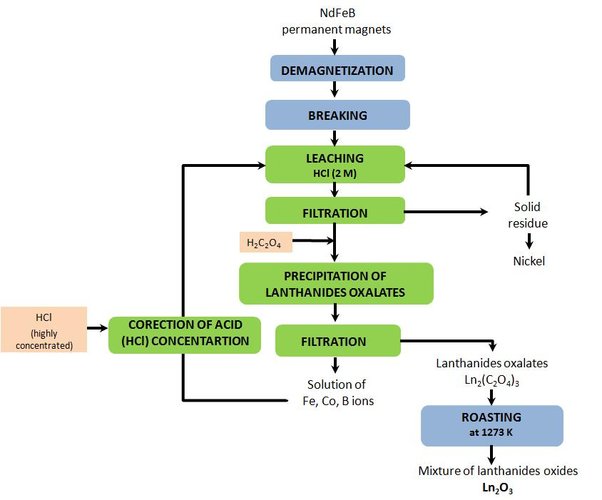
Fig. 1. Scheme of the developed method for recycling of NdFeB permanent magnets

